**ETHNUS**

**Building a Face-Detection App on AWS**

**Name : M.K.HEMA**

**REG NO : 16MIS0145**

**COLLEGE : VIT UNIVERSITY**

**VELLORE**

**Screenshots for Dashboards**

1. **AWS Login screen with username**

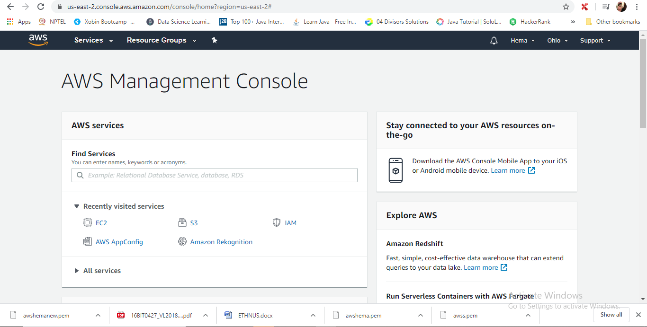

**2. EC2 Dashboard**

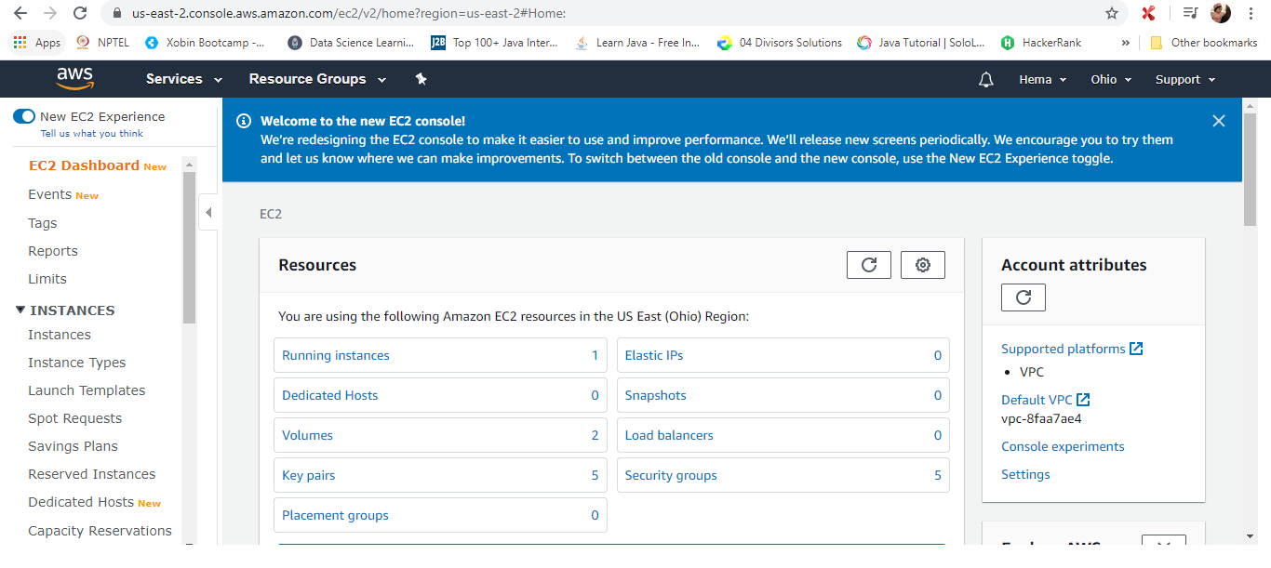

**3. S3 Dashboard**

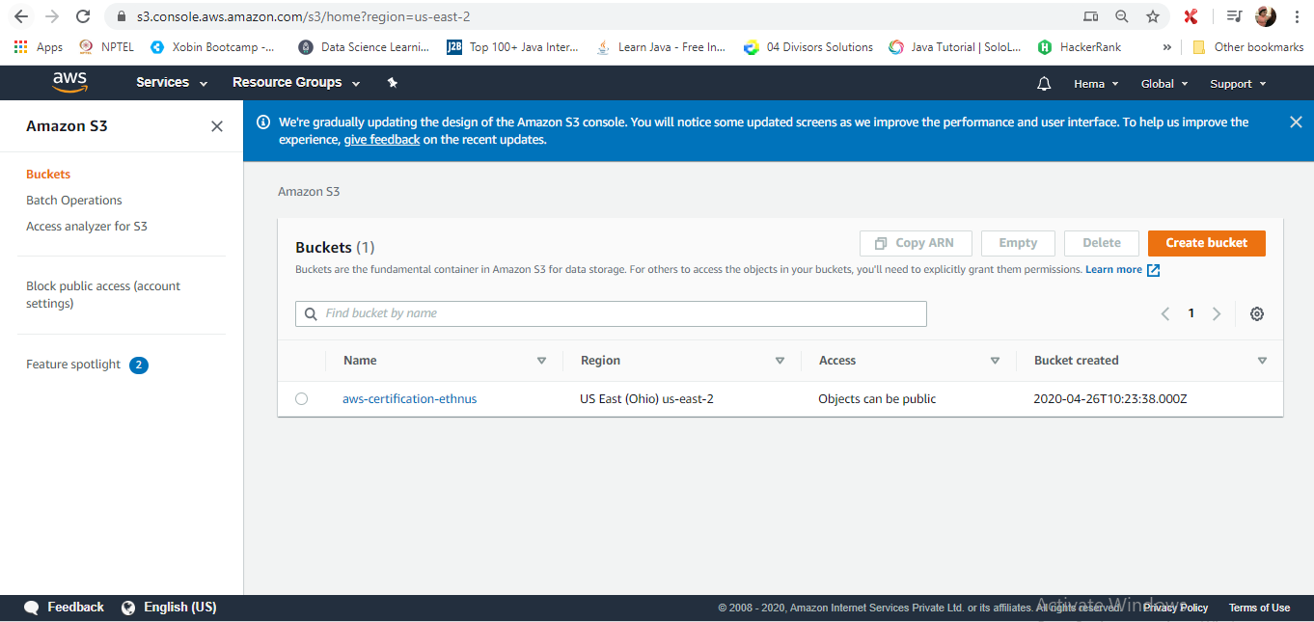

**4. Rekognition Dashboard**

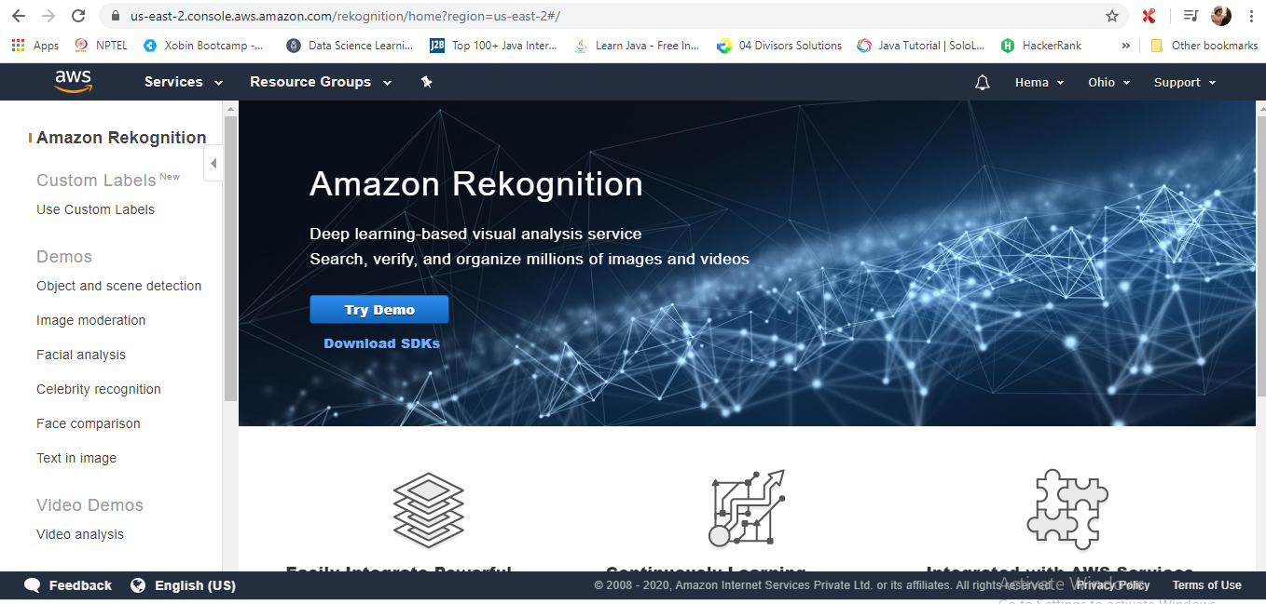

**Screenshots for EC2**

**1. Choosing an AMI**

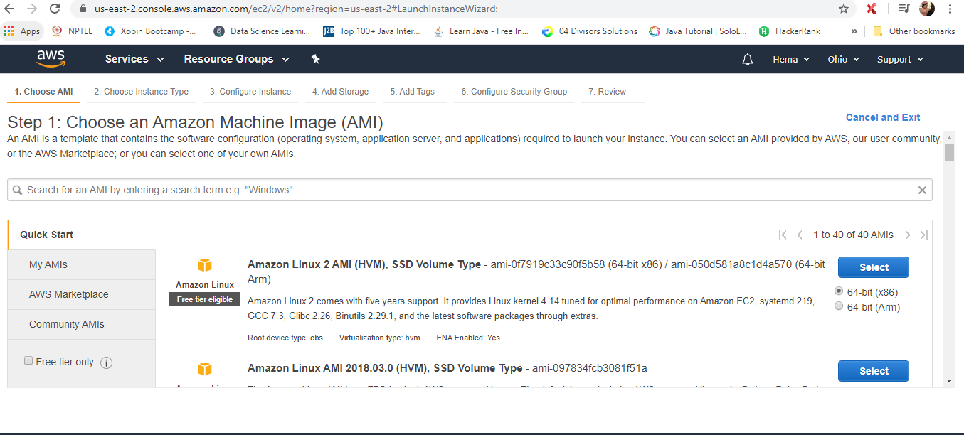

**2. Choosing an Instance Type**

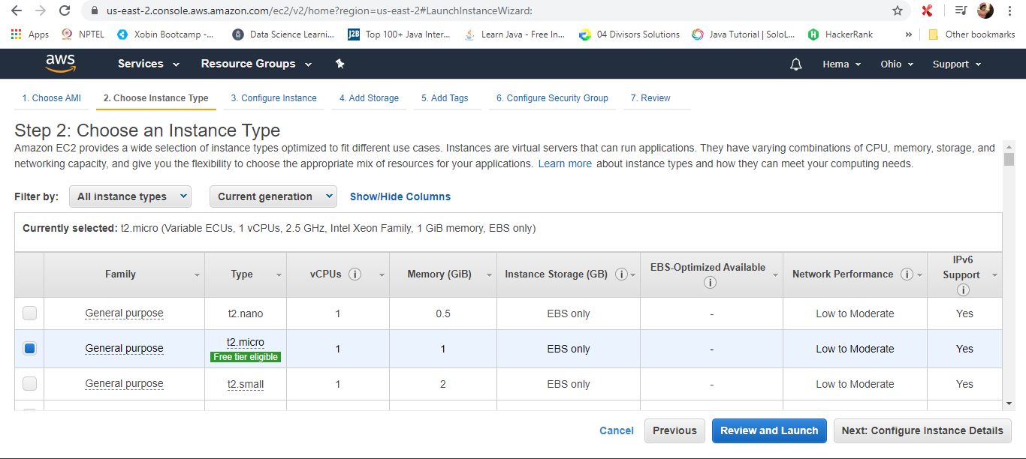

**3. Adding Storage**

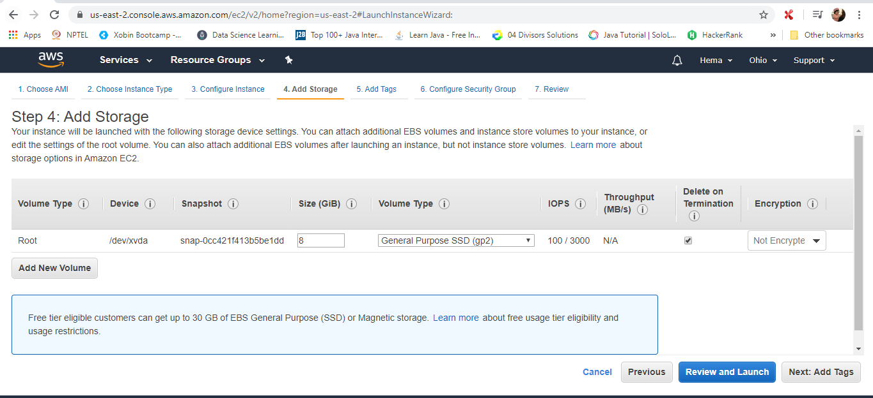

**4. Configuring Security Group**

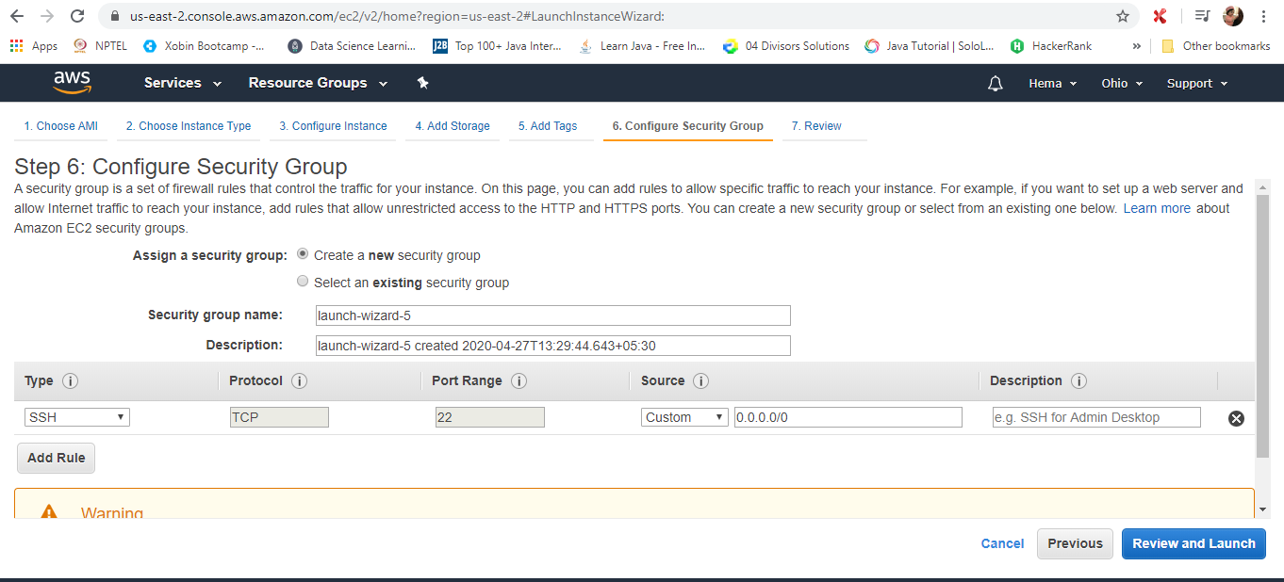

**5. Key Pair Download**

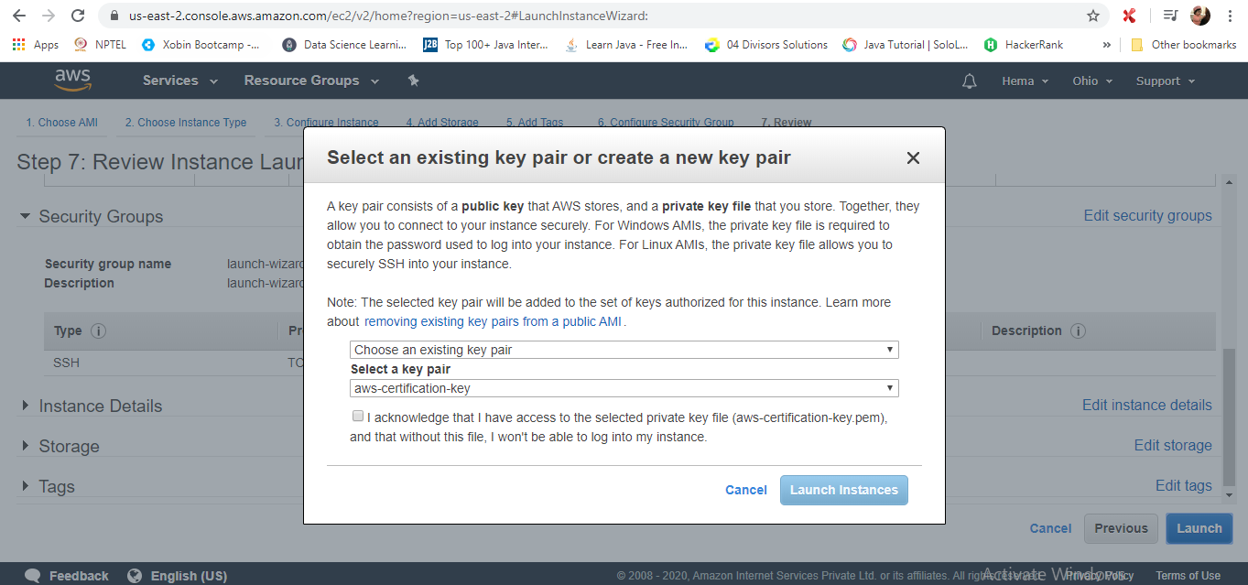

**6. PuTTYgen conversion from pem to ppk**

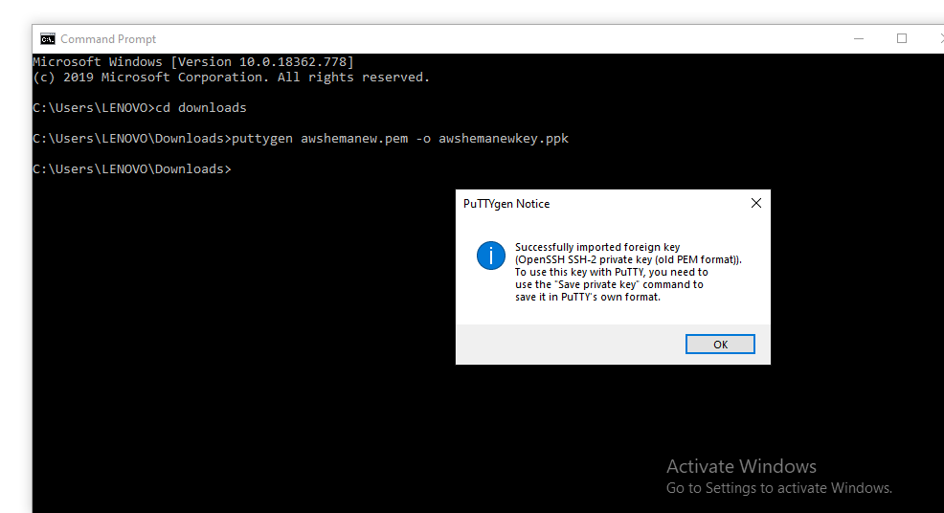

**7. Logged in EC2 black screen**

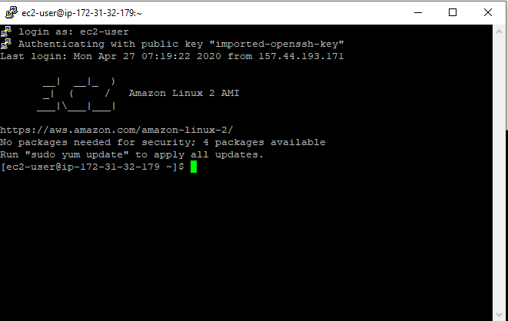

**Screenshots for S3**

**1. Creating a bucket**

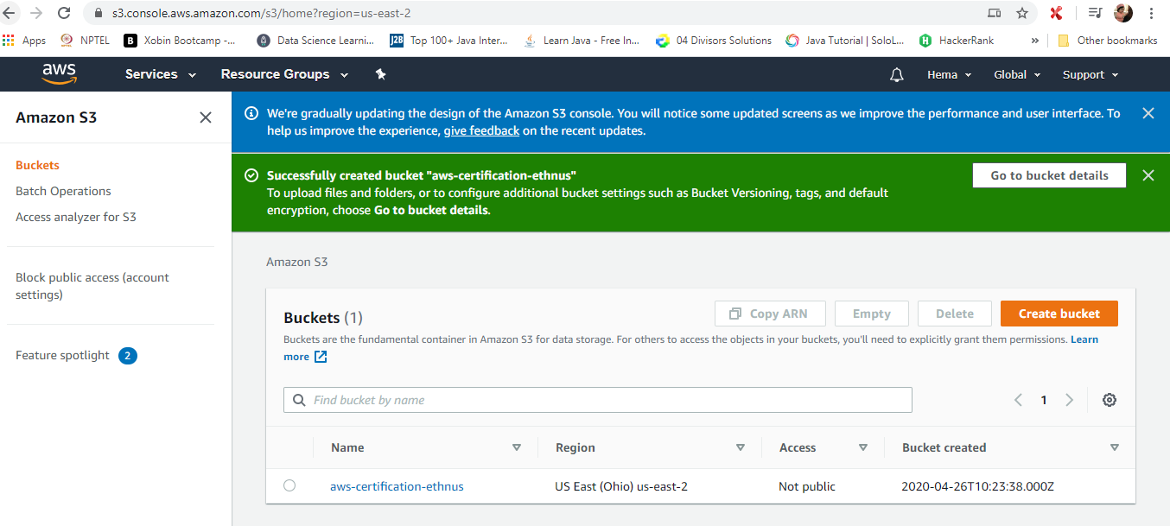

1. **Uploading an Object**

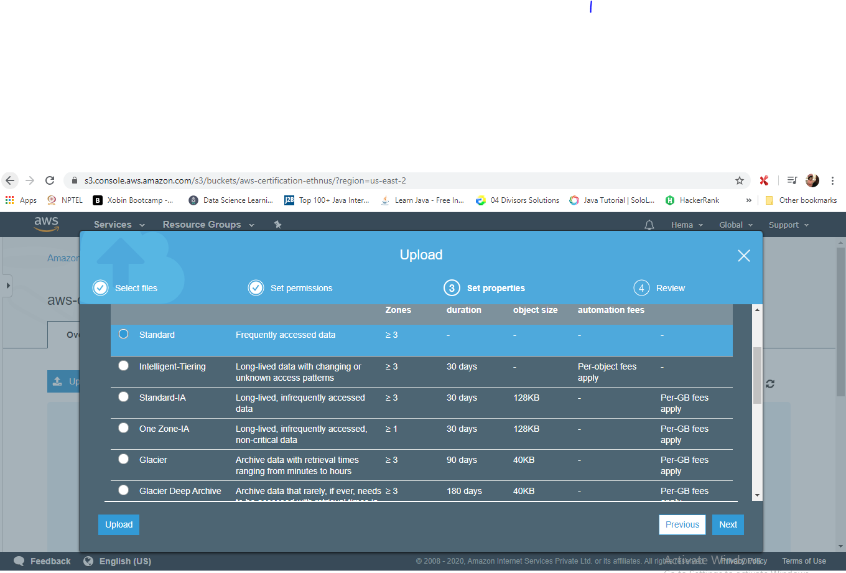

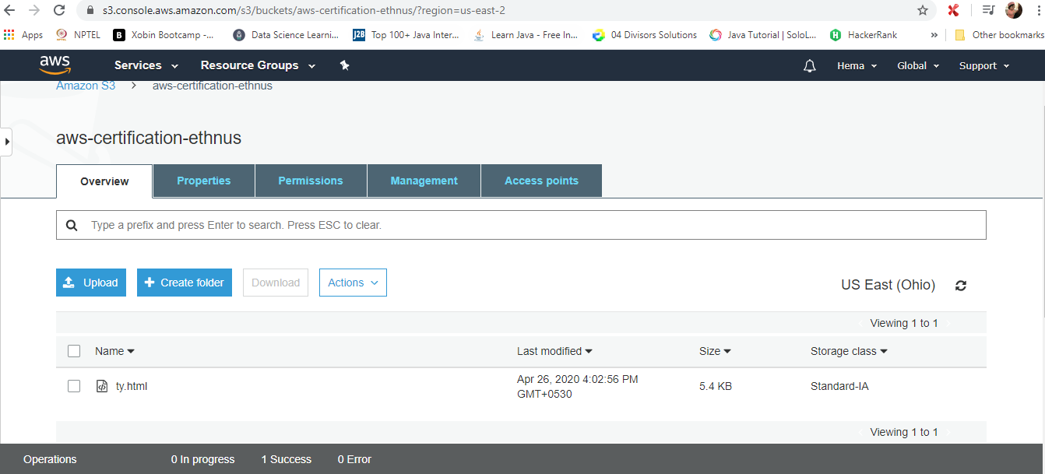

**3. Enabling Static Website**

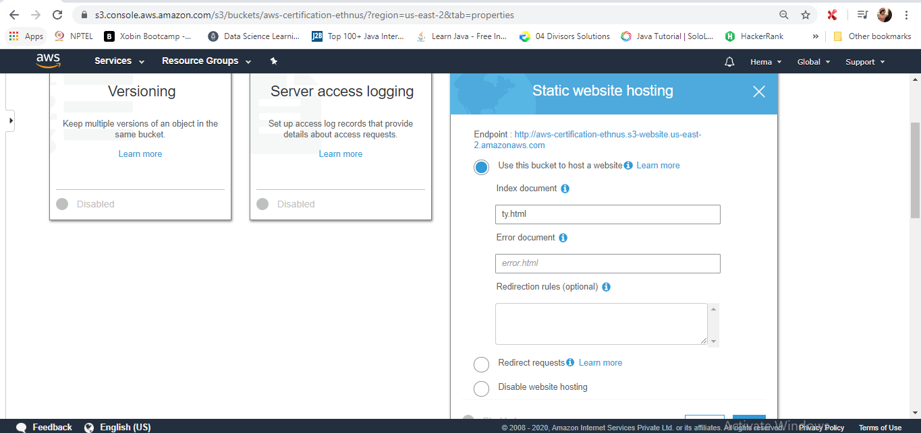

**4. Making the Object Public**

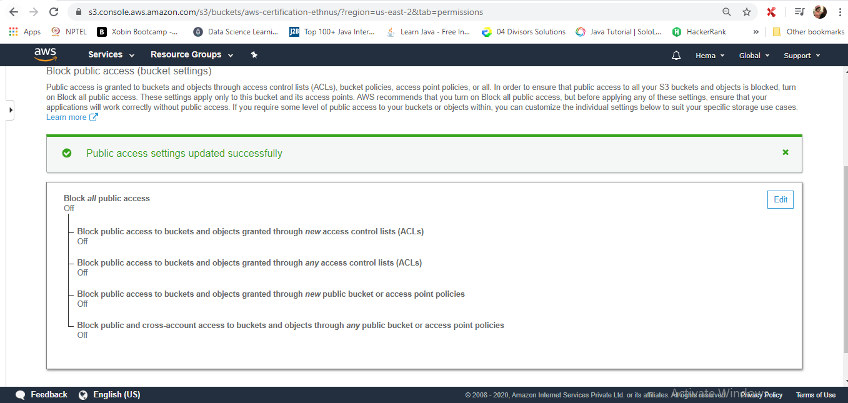

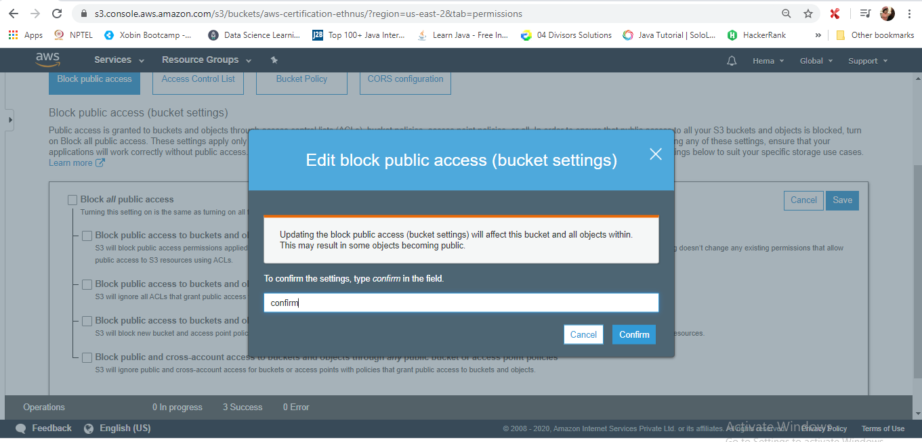

**5. Checking the S3 link on the browser**

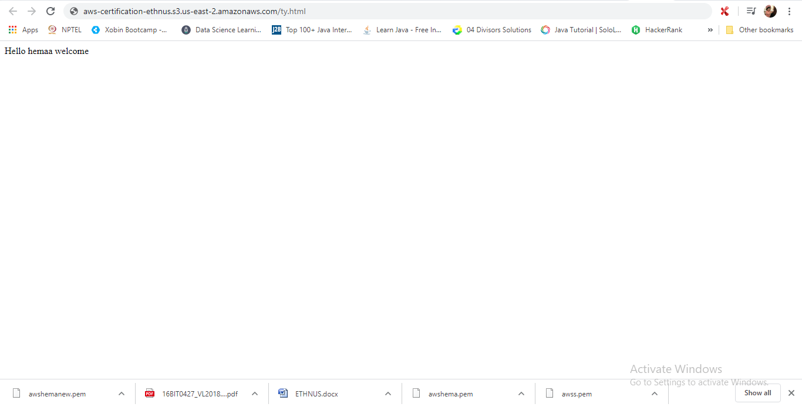

**Screenshots for Rekognition**

**1. Face Detect**

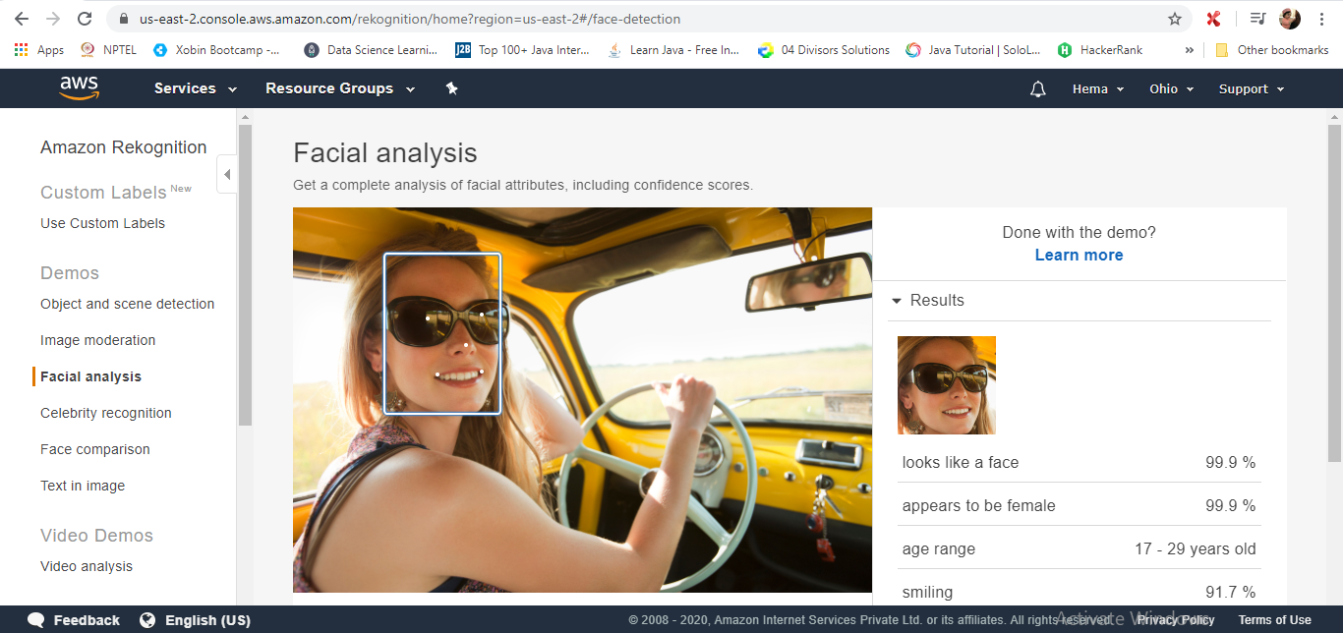



1. **Celebrity Recognition**

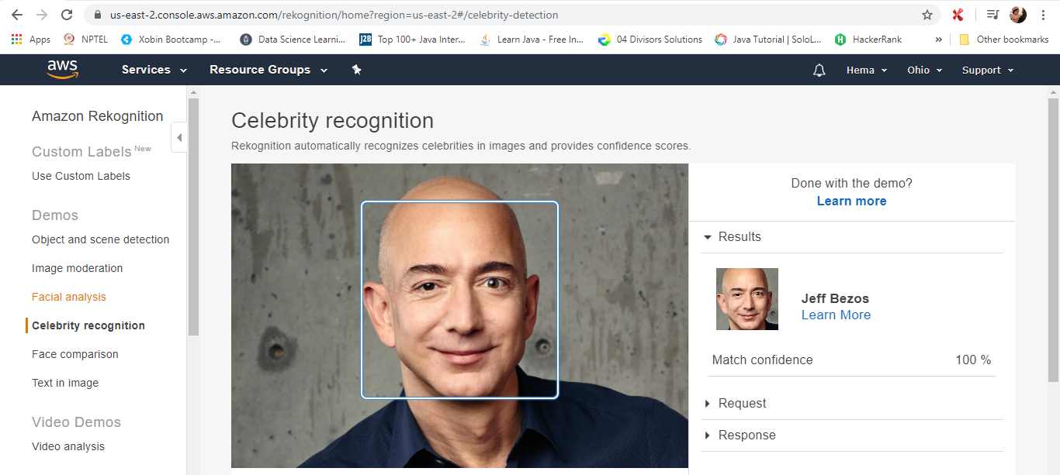

**3. Face Compare**

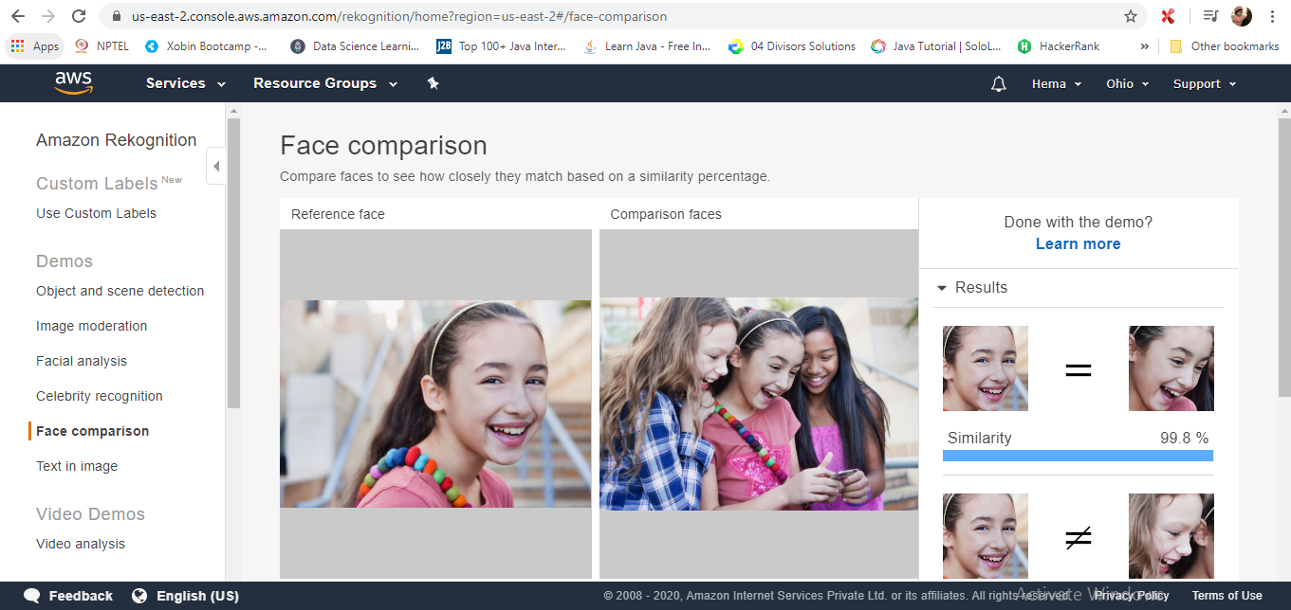

**4. Text in Image**

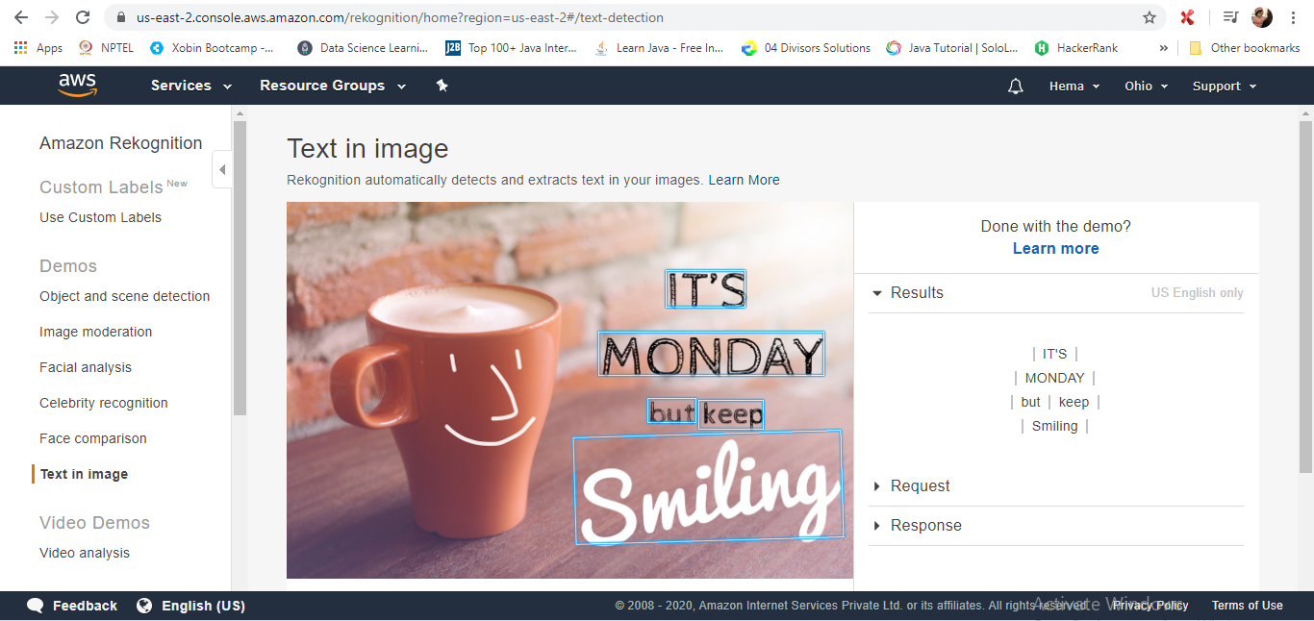

**Screenshots for EC2 & S3**

1. **Installing php**

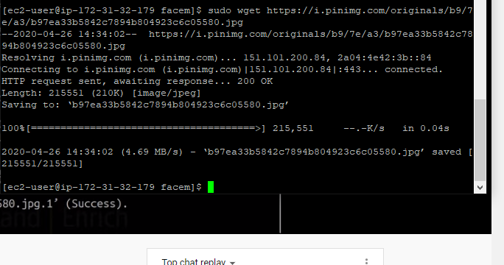

1. **index.php file code**

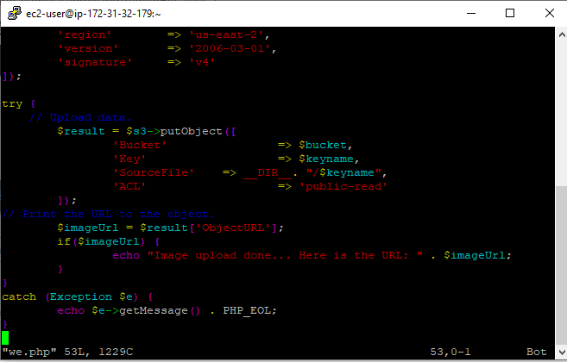

**Screenshots for EC2 & Rekognition**

**1. Face Detect success screenshot**

